Phishing Process SOP

- Internal campaign details
- Actions to take during an email reported by a user
- Investigation steps
- Post Investigation
- Contacting IR

Internal campaign details
- internal campaign details are notified by GSO.

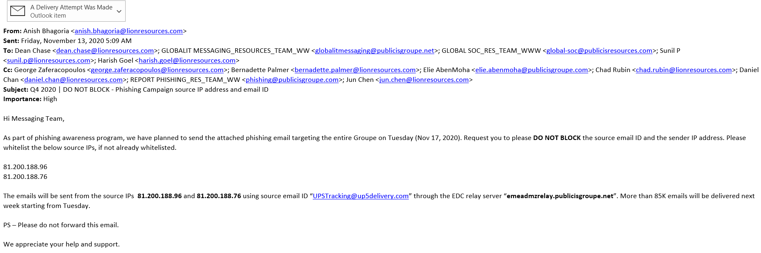
- Campaign details should contain
  - ID of the email
  - Subject of the email
  - Targeted audience
  - Timelines - start and end date/time
  - Point of contact from GSO side
  - Campaign email that will be sent
  - message displayed when the link is clicked by the user

- Response to users who have reported to us

Normal user’s
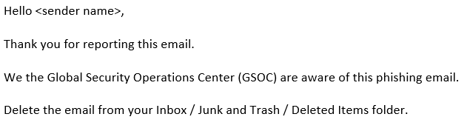
Executive user’s

Actions to take during an email reported by a user
- When the user has used user submission button

  - When the email is legitimate, we must respond to the user stating that the reported mail is legitimate.
  - When the email is spam, we can ignore and if the same user reported multiple emails using the submission button which identified as spam, then we can respond him/her in one mail stating that “The mails that reported are spam emails” using SPAM template.
  - When the email is phishing, we must respond only to the reported user using phishing template. do not respond to all the recipients of the email. Instead respond only to users who have clicked the link [Especially “Blocked and click through” and allowed]
  - When the email is whaling - CEO fraud, we must respond to the reported user and users who all are received in their inbox. User’s list can be exported from O365 explorer.
  - Explore and understand how the button works

- When the user has confirmed it is malicious and reported
  - Investigate whether the claim is true
            - When it is true –
              - When we identified that the mail is malicious/Phishing, follow 1(c)
                - if the recipients are more than 100, then we can contact the messaging team to block the sender. Inform Sunil or Puneeth
              - When we identified that the mail is CEO Fraud/Impersonation Fraud, follow 1(d)
                - For Identified CEO fraud mail, if the recipients are more than 25, then we can contact the messaging team to block the sender.
                - If it is Bitcoin/Blackmail/finance - we must tell the user to not to proceed further with that mail communication

            - When it is false –
              - When we identified that the mail is SPAM or Legitimate (False), We must respond only to the reported user using SPAM/Legitimate template.

            - When the user has acted(responded) on that email
              - When the user responded to the Suspicious mail in the below scenarios,
                - If its Credential harvester –check with the user whether he/she just clicked the URL or provided credentials. If he/she provided the credentials, ask user to change the password immediately and make them aware not to click any URL from unknown senders. Refer IR (5)
                - If its CEO fraud mail where the user responded, advise user to not to proceed further with that mail communication and make the user aware to always check for sender before responding. Refer IR (5)
                - If it is Malicious attachment/suspicious URL, we must tell the user to contact the local IT team to scan the machine for any detection and check for any suspicious activity for that user machine. Refer IR (5)
                - If it is Bitcoin/Blackmail/finance - we must tell the user to not to proceed further with that mail communication

            - When multiple users are affected
              - If the multiple users affected, we must check in above mentioned scenarios for this case also and added to that we have inform to the management about this case.

                - If its Credential harvester – follow 3 (a). (i)
                - If its CEO fraud mail - follow 3 (a). (ii)
                - If it is Malicious attachment/suspicious URL - follow 3 (a). (iiI)
                - If it is Bitcoin/Blackmail/finance - follow 3 (a). (iv)

- When the user is asking for further steps
  - Multiple spam emails even after marking it as junk
    - emails from same sender will be delivered to junk folder, ask user to ignore the mails that are received in junk and delete.
    - If the mail is receiving to their inbox after marking as junk, then we can loop the messaging team to look at the issue.
  - Explore actions on unsubscribing the email - unsubscribing the mail only if we identified that the URL for unsubscribe is safe/clean/not malicious

- When the reported user is an executive user
        - Initial phase – investigate Refer (2), identify assistant, details to be documented and sent it to management for response

        - Final phase - Make it a person independent repeatable process
          - Identify scenarios
          - Create a template for sending message - probably take Amit B's help
          - Train the team / test it
          - Operationalize it

- What action to take when multiple users are reporting
  - If Multiple users are reporting the same email,
    - If the mail is suspicious/Phishing, we have to respond all the users who reported it and users who all are received in their inbox. User’s list can be exported from O365 explorer.
    - If the mail is spam, just respond to the only reported users.
    - If the mail is legitimate, just respond to the only reported users.
  - Same subject but different content,
    - If the mail is suspicious/Phishing, we have to respond all the users who reported it and users who all are received in their inbox. User’s list can be exported from O365 explorer.
    - If the mail is spam , just respond to the only reported users.
    - If the mail is legitimate, just respond to the only reported users.
  - Similar subject and content
    - If the mail is suspicious/Phishing, we must respond all the users who reported it and users who all are received in their inbox. User’s list can be exported from O365 explorer.
    - If the mail is spam , just respond to the only reported users.
    - If the mail is legitimate, just respond to the only reported users.

Investigation steps

    - Determining spam vs phishing
    - Phishing
      - Through threatgrid
      - Through O365
    - Malware
      - Through threatgrid
      - Through O365
      - Through AV action
    - Action items
      - Create SOP for:
        - Determining the different ways to identify spam vs phishing
        - Determining the different kind of phishing and their priority based on their impact eg. cred harvester vs financial whaling attack
        - Determine/understand the way different O365 ATP tools work- document/training
        - Determining the different malwares involved, their impact and remediation step required for it.
5. Determining the function/effectiveness of the various tools we have for malware protection
Determine the way different O365 ATP tools work document
Step 1: Identify malware infections in our environment.
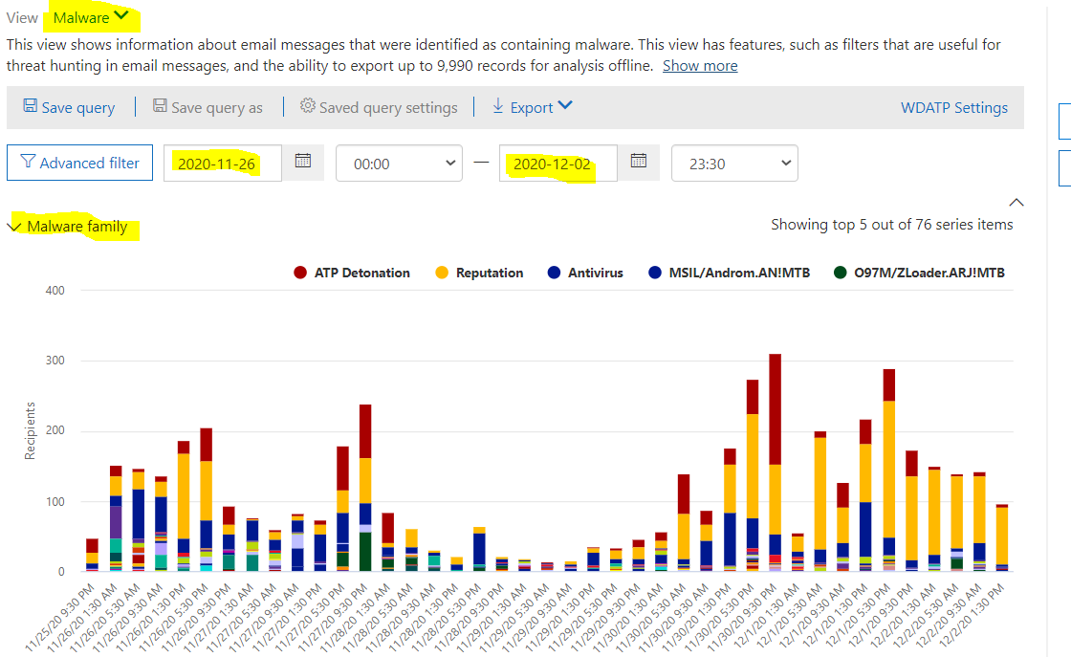

Step 2. Top Targeted Users by Malware
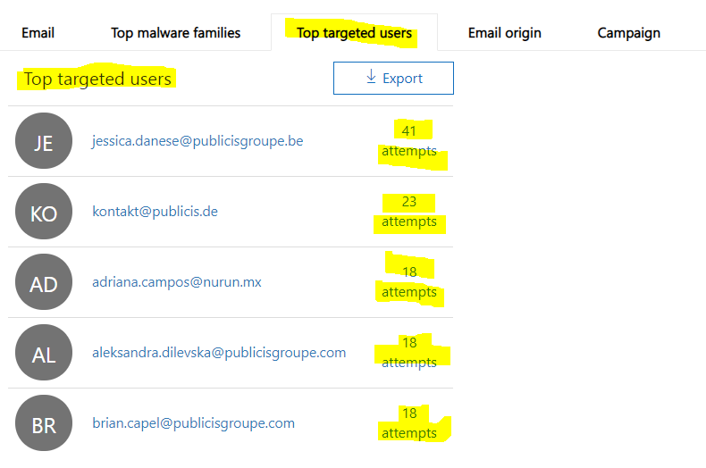
Step 3: Verification based on infected user.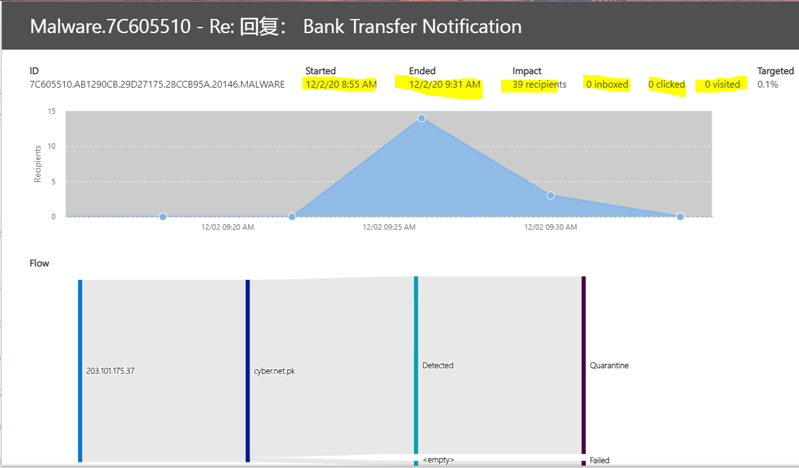
Step 1: Identify Phishing attack
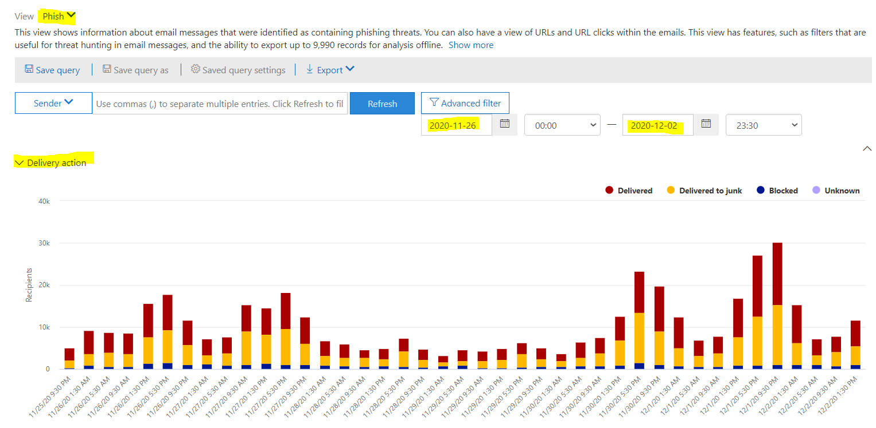
Step 2 : List of Email
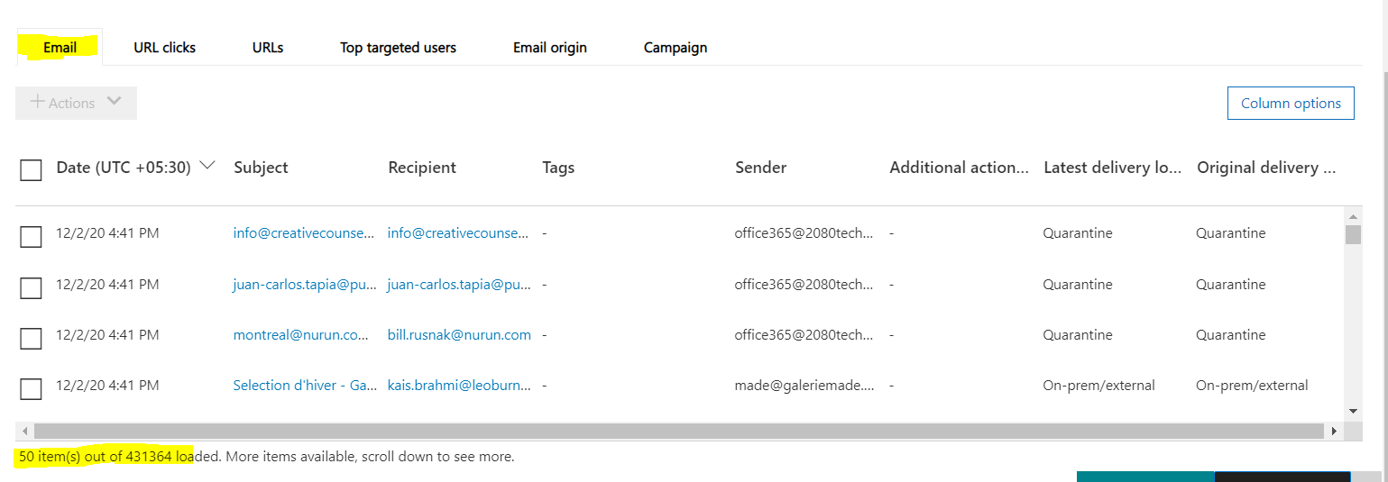
Step 3 : URL Clicks Dashboard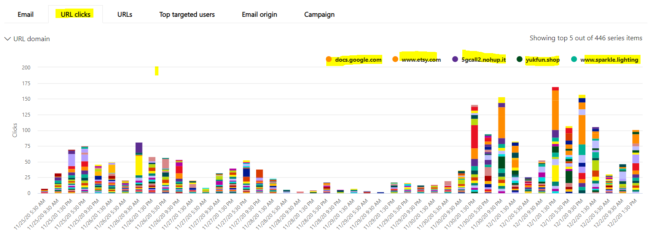
Step 4: Top User Clicks are Allowed
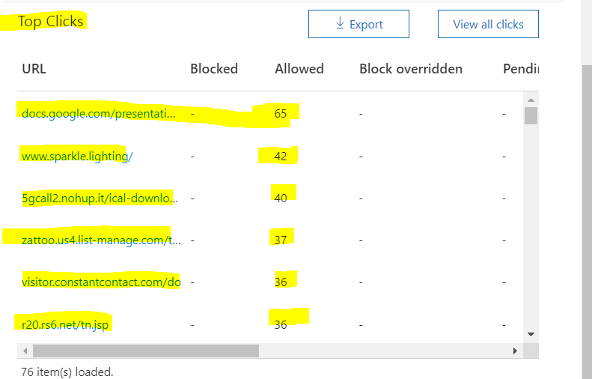
Step 5 :Top Targeted Users of Phishing attack
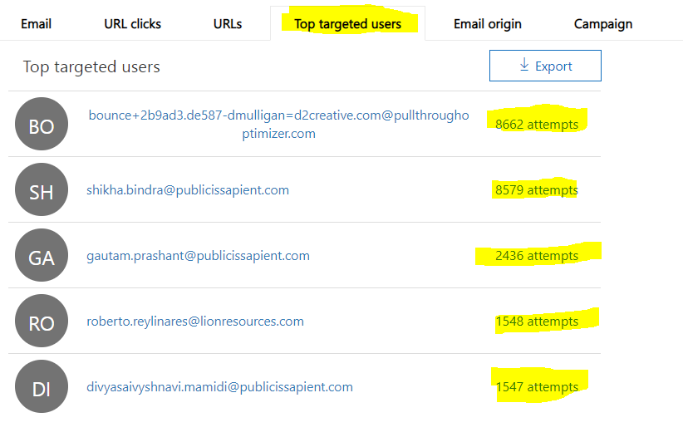
Step 6: Through Campaign Dashboard , we can identify top targeted user.
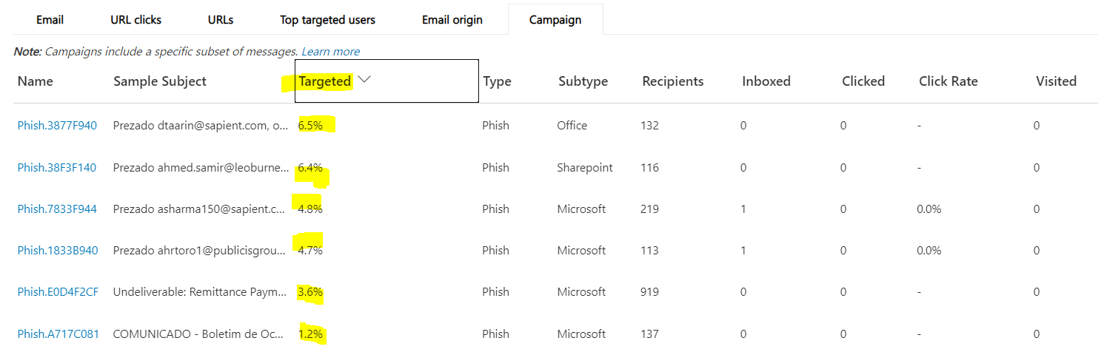

Post investigation
- Respond to single user for spam
- Responding to multiple user for spam
- Phishing
      - Identifying the recipients who have received this email
      - Identifying whether mail is URL or attachment
      - Identify the subject and determine if it can trap the user
      - Check in O365 whether the user has clicked the URL/override
      - What to do if safelink isn't blocking the URL
      - When to mass mail users proactively
      - When to keep management in loop
      - How and when to respond back to executives
      - Action items
        - To answer the question on whether to reach out to multiple users proactively and if yes, when to reach out and when not.
        - To review templates for spam response - also look at automating this
        - Create SOP for point c
        - Weekly review of all URLs that have been blocked-overridden
        - Weekly review of all the malwares that have been identified by the system (O365)

When to Reach out multiple Users

- If the Sender address is spoofed with Publicis Groupe internal domain, CEO Fraud, Spear Phishing and the mail is delivered to multiple user’s inbox.

- If the URL is Credential harvester (Based on user clicks) or it downloads any malicious file into System and the mail is delivered to multiple user’s inbox.

- If the attachment is Malicious and the mail was delivered to multiple user’s inbox.

Not Required

- If the Phishing or Malicious Mail is delivered only to one user.
- If the URL If the URL is Credential harvester and there is no user clicks. Respond only to reported user.

Spam Template

If the Mail contains any Unsubscribe Link then Spam response can be used.

Identifying the recipients who have received this Mail.
Login to
- https://protection.office.com/messagetrace

Select Threat Management - > Explorer.

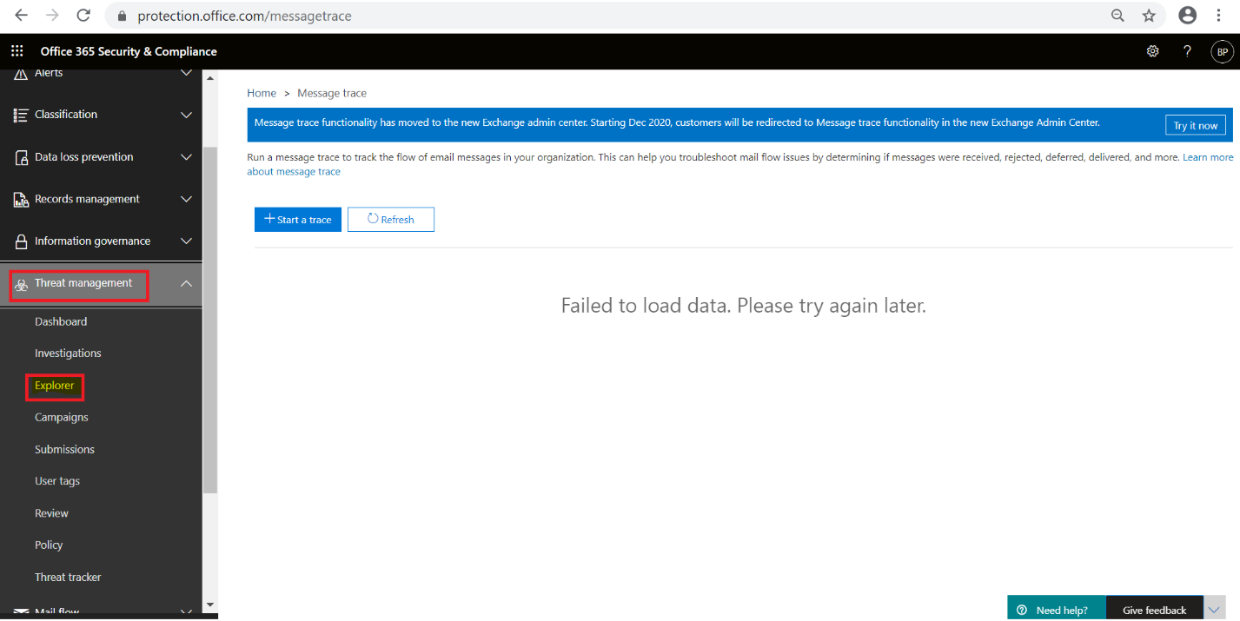

Step 2 – Select All Mails in View Menu as shown below.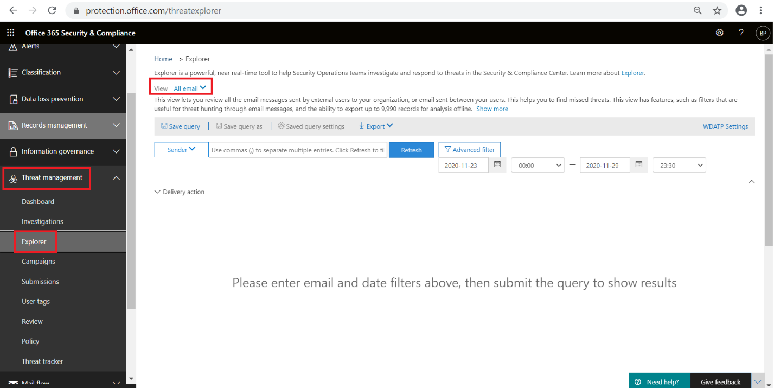

Step 3 – Advanced Filter.
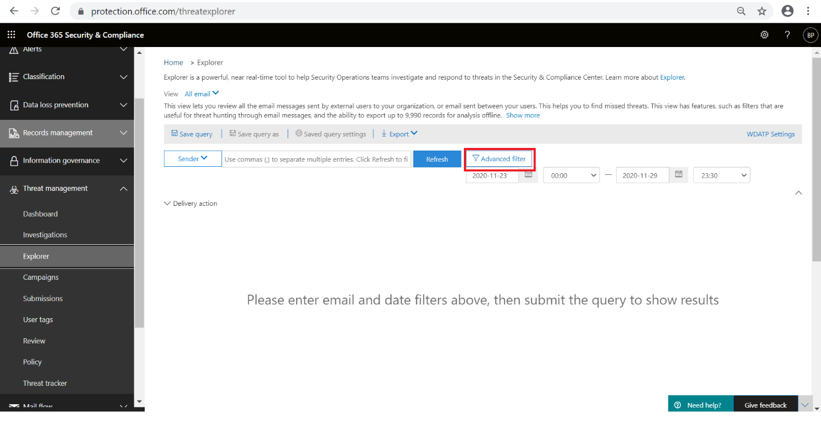

Steps 4 – Click Add a Condition
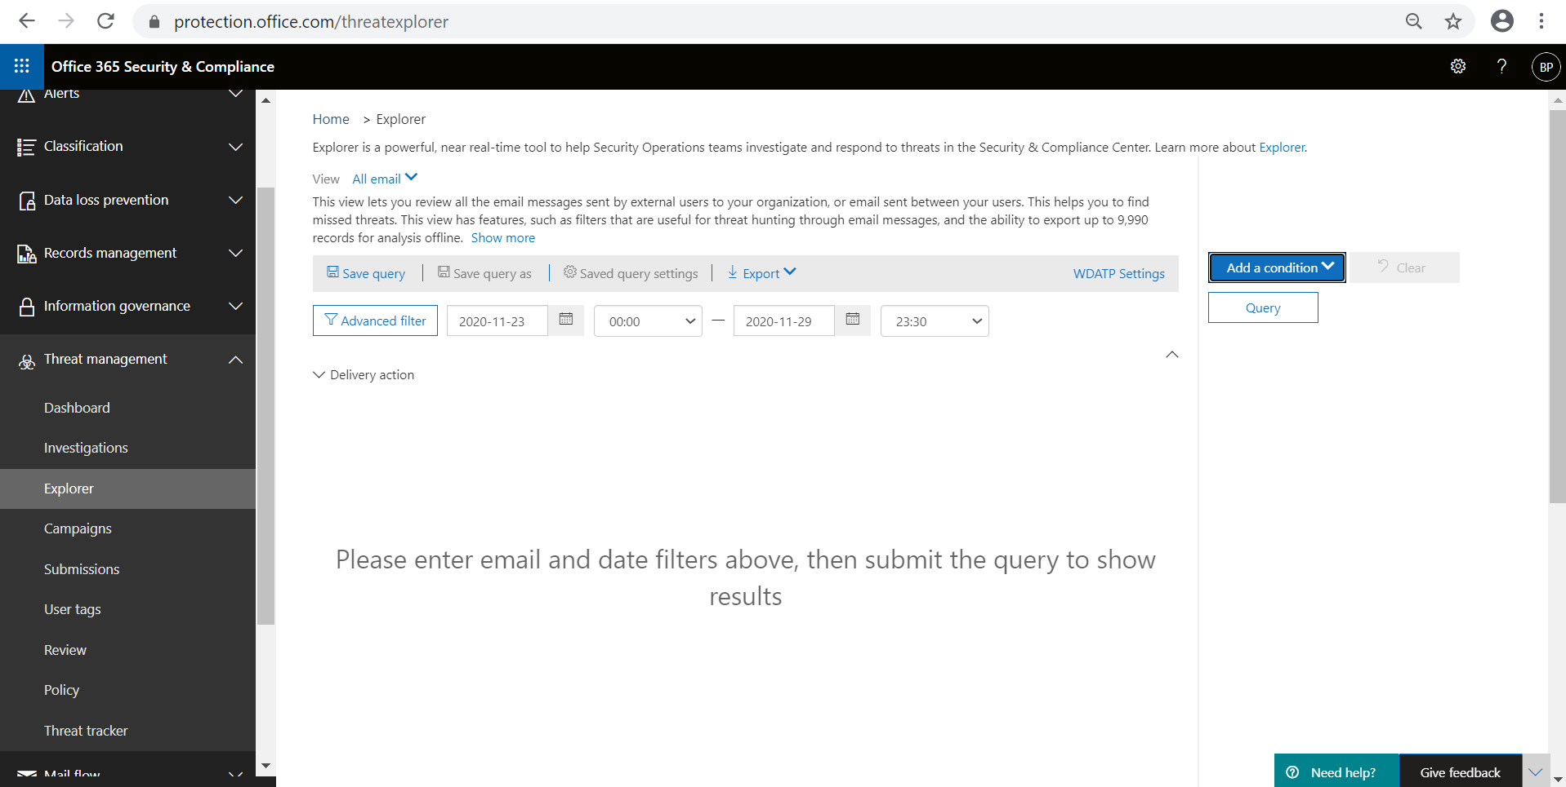

Steps 5 – From the Drop down we have to select the field based on requirement.

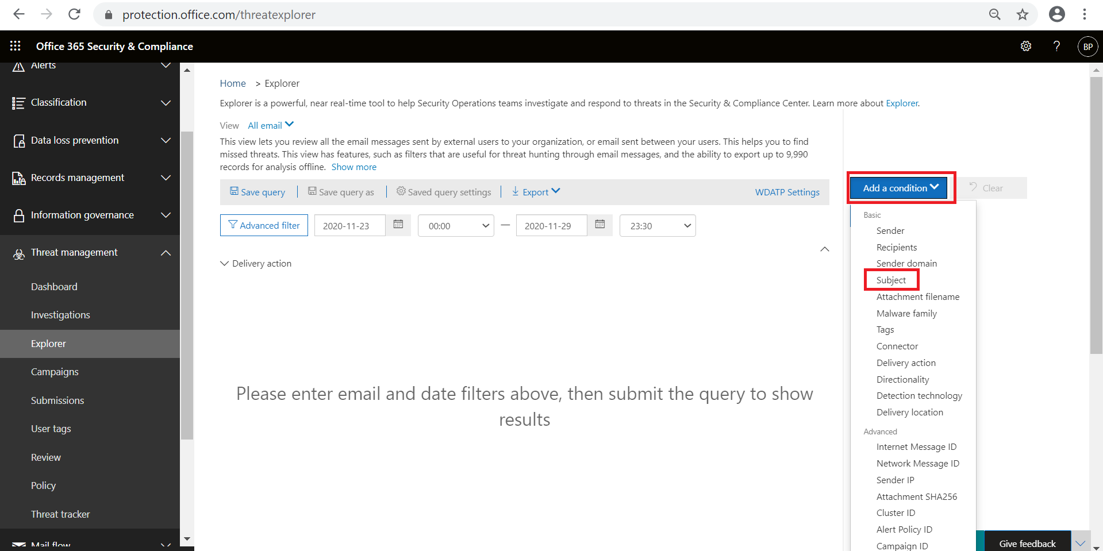

Steps 6 – Select time line, Add Sender address and Delivery Location as Inbox. Then Click on Query.

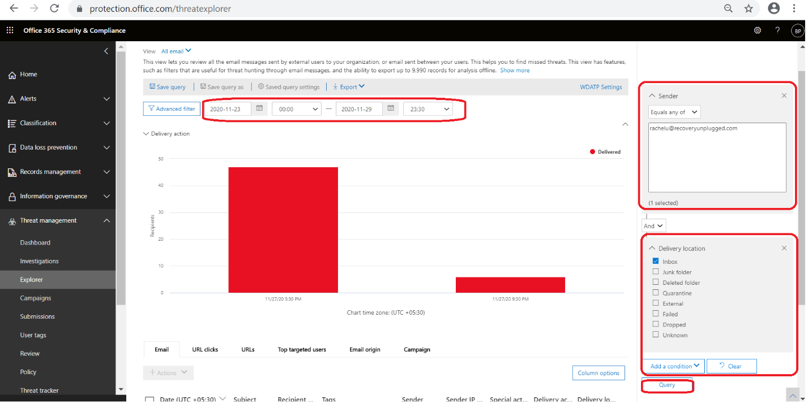

Step 7 – At the bottom we will get the Total number of Recipient who has received the mail from this sender. We can export the details in csv format by using Export menu -> Export Email List button as shown below.

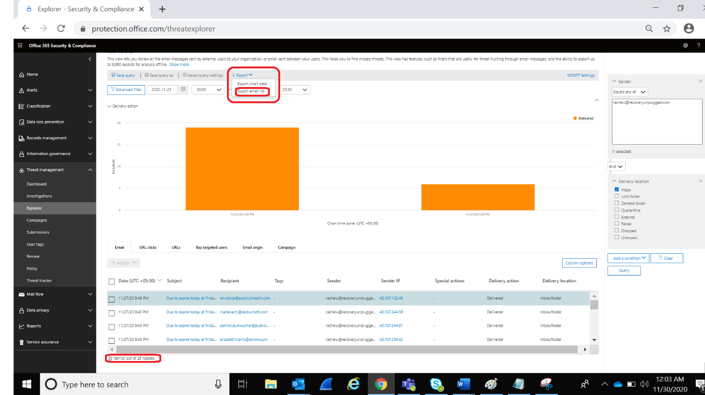

The Exported List contains all the details about that mail.

To identify the URL and Attachments.

Step – 1 - Click on the Subject Line of the Mail.

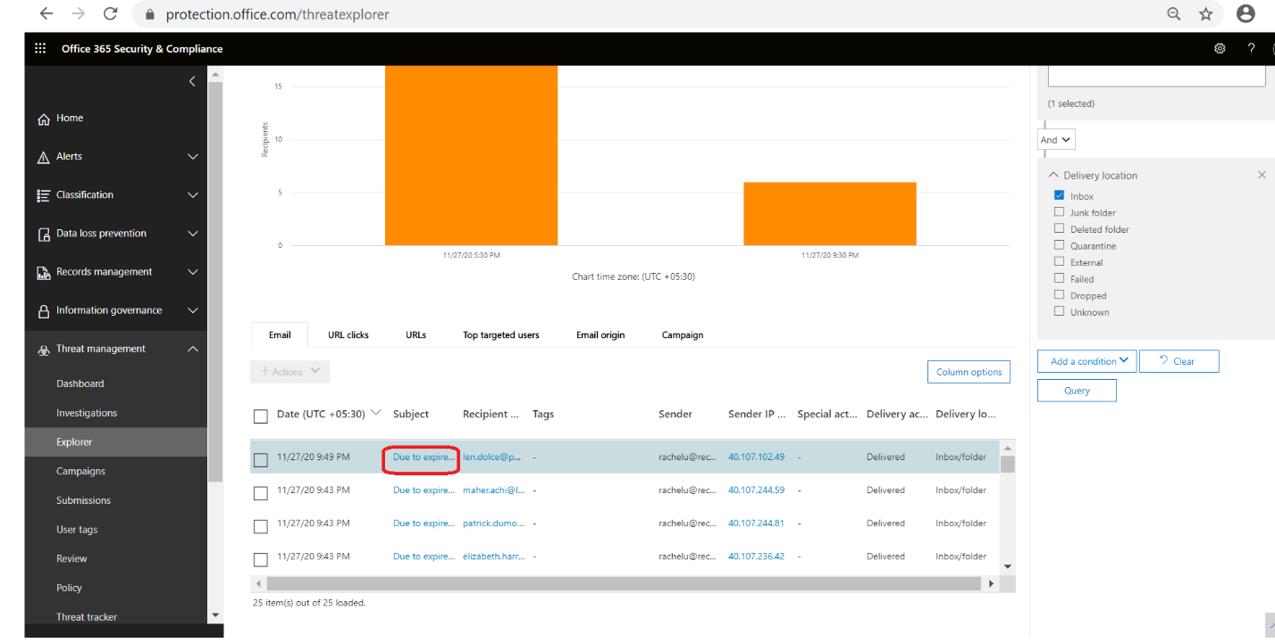

Step 2 – Go to Details Tab.
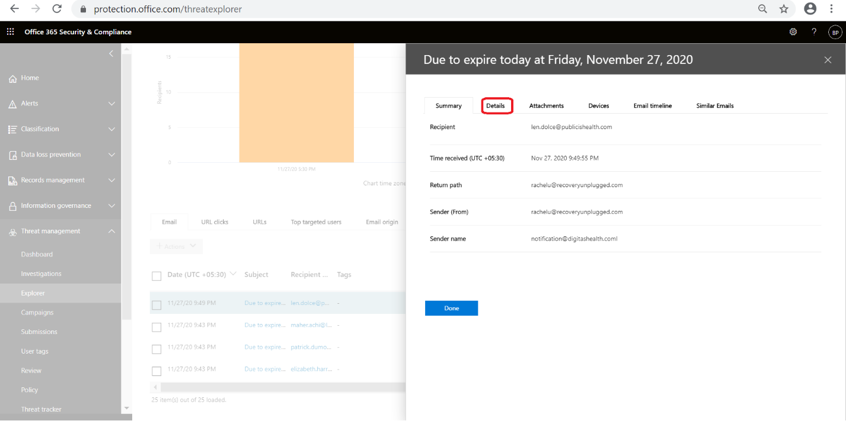

Step 3 – Here we get all the URL exist in that mail.
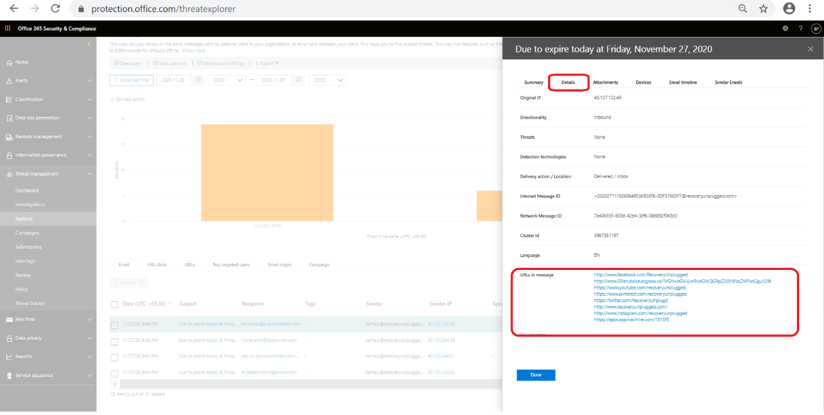

Step 4 – To check the Attachment Go to Attachment Tab as shown below.

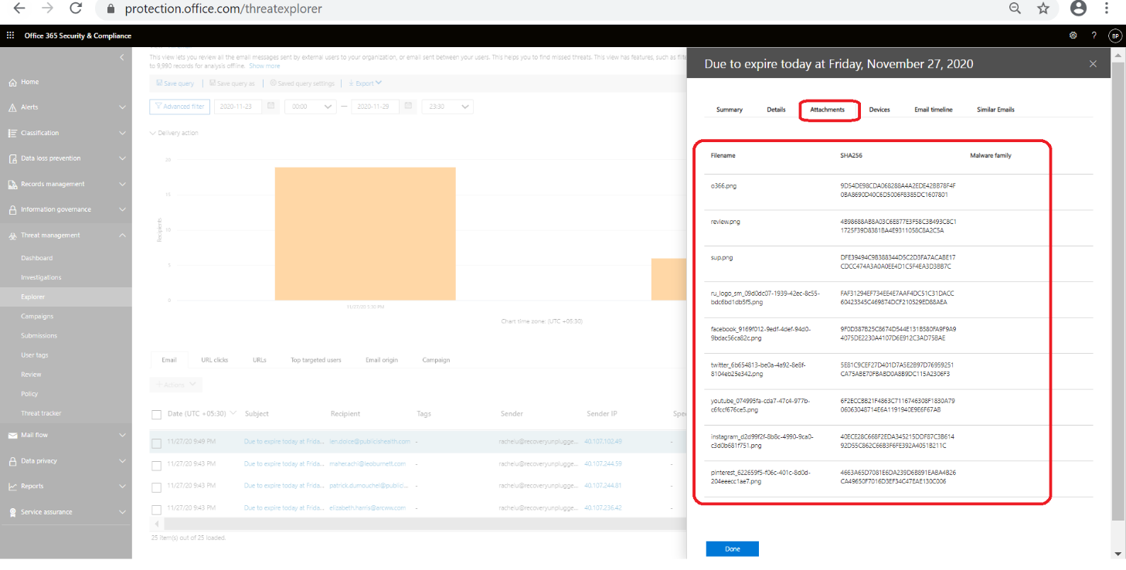

Identify the subject and determine if it can trap the user

Identify the Subject whether it can trap the user like Invoice, Meeting Invitation, Important Communication etc.
Ex - You received a video conferencing invitation. Thursday, 26, 2020 10:55:20 AM

URL Clicks.
Step 1 – Go to URL Clicks menu

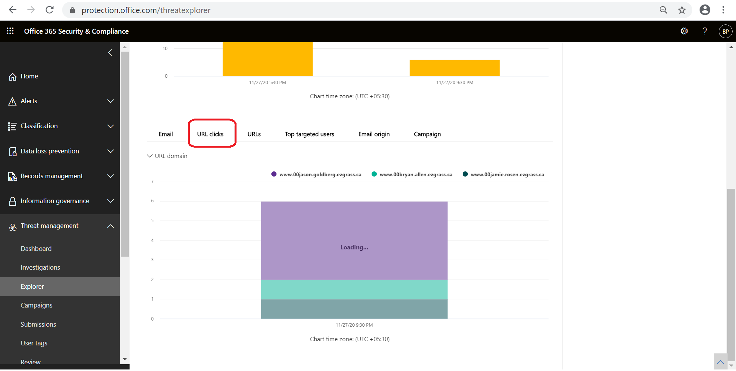

Step 2 – Select Click Verdict

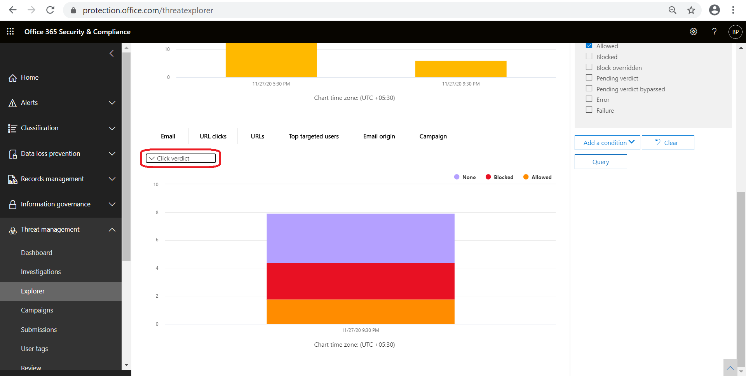

Step 3 – By using Additional Condition Click Verdict – Allowed we can identify the URL Allowed users List.
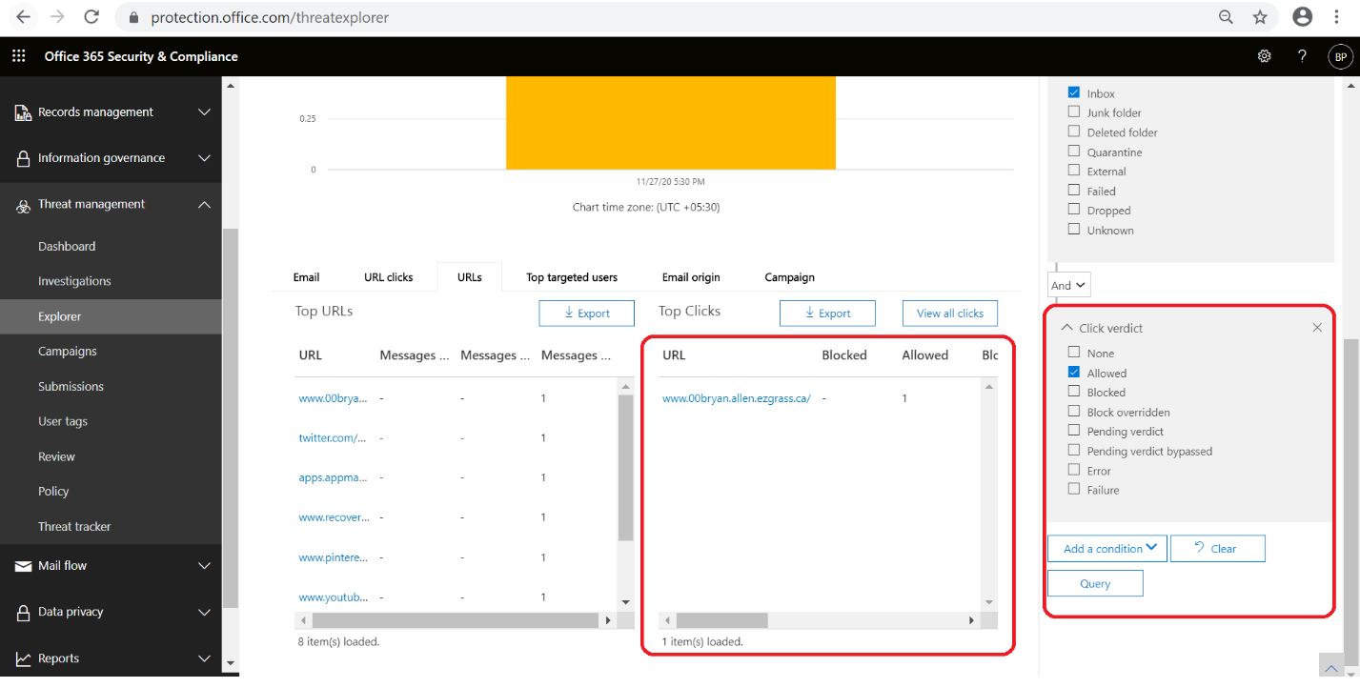

What to do if SafeLink isn't blocking the URL.

Need to Create Policy to block the URL.

When to mass mail users proactively.
Once the reported mail is identified as Mass Phishing Campaign and After the Management Approval.

When to keep management in loop
Once the reported mail is identified as Mass Phishing Campaign.

How and when to respond back to executives.
- If the URL is Credential harvester (Based on user clicks) or it downloads any malicious file into System and the mail is delivered to inbox.
Template to be decided.

Weekly review of all URLs that have been blocked-overridden

Step 1 – By Selecting the below options we can Review the URLs that have been blocked-overridden.

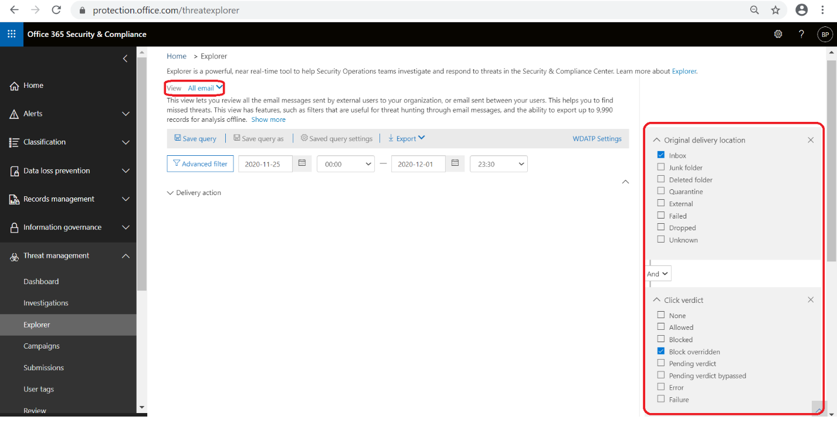

Weekly review of all the malwares that have been identified by the system (O365)
Step 1 – Bye Selecting below details we can review the Weekly Malwares that have been identified by the System(O365).
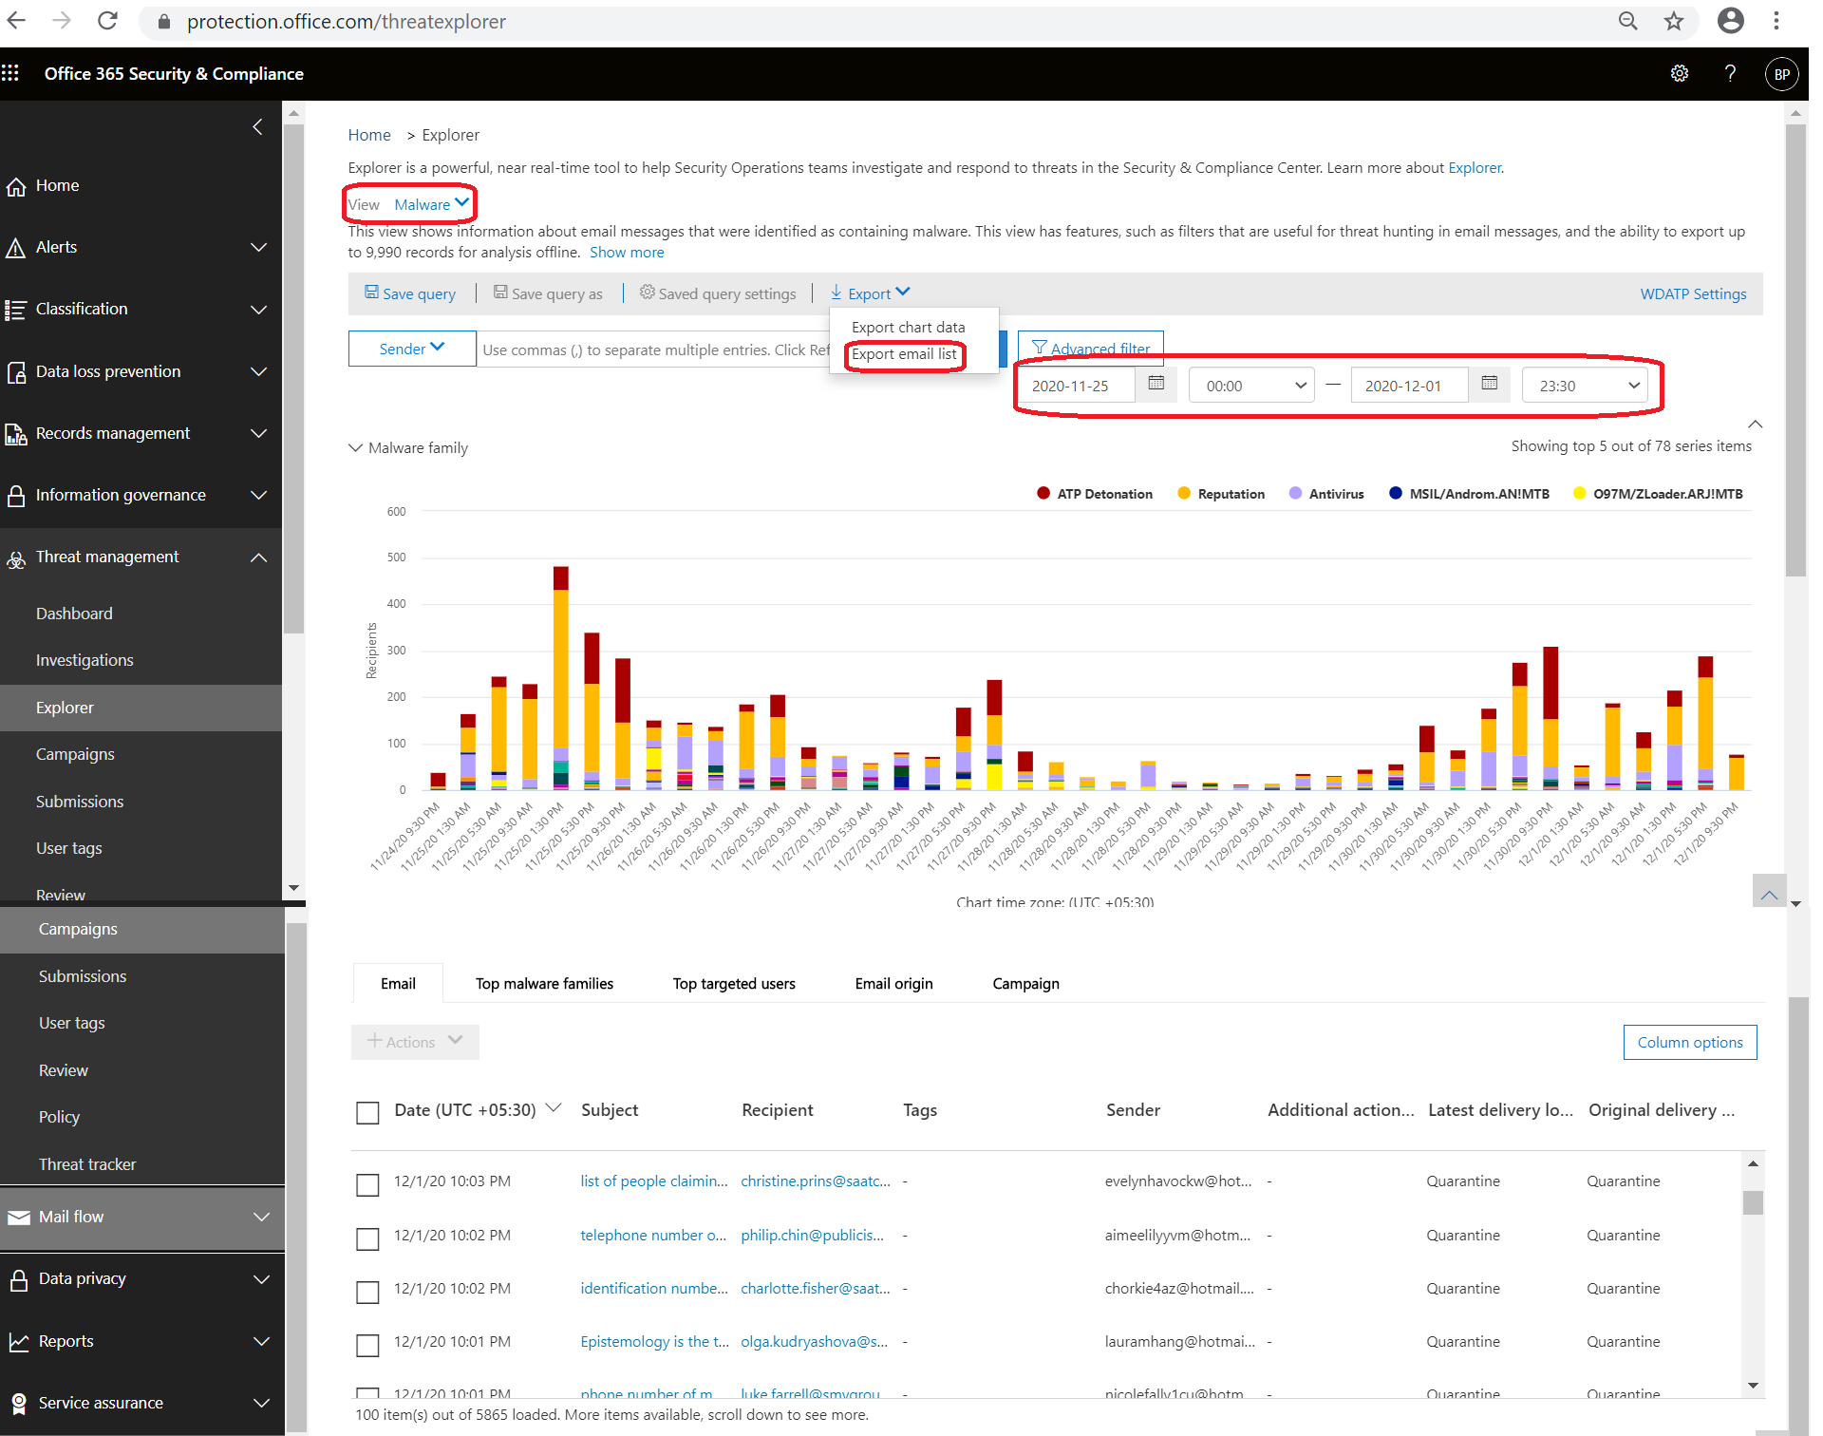

Contacting IR
IR contact DL: GSO INCIDENT RESPONSE_RES_US <reportincident@publicisgroupe.com>
When to contact IR team:
Credential harvester mails: If user clicks the link and provide password
User opens any malicious attachments came through e-mail

Case 1:
Details to collect:
Credential harvester mails:
Login to portal.azure.com
On search tab type user’s
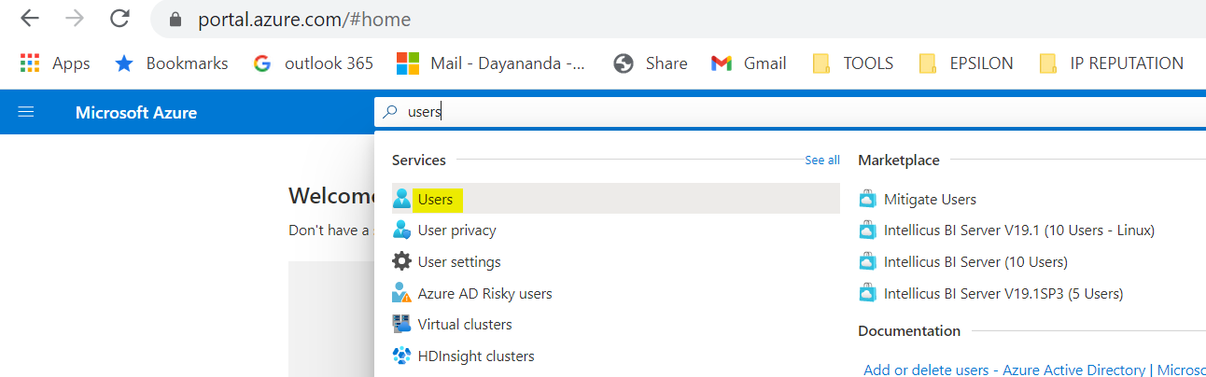
Search for the user who clicked the link
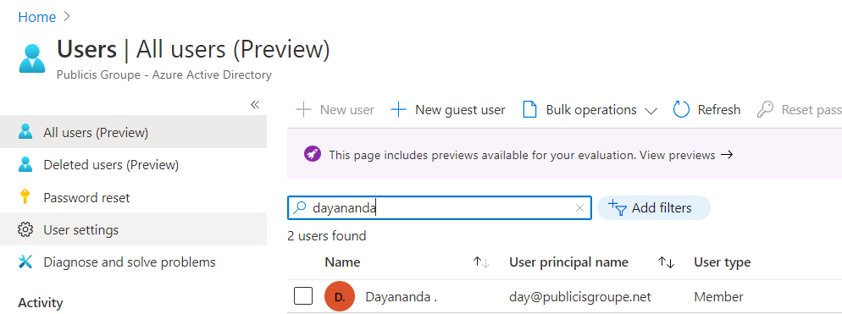

Check for geolocation of user sign in’s
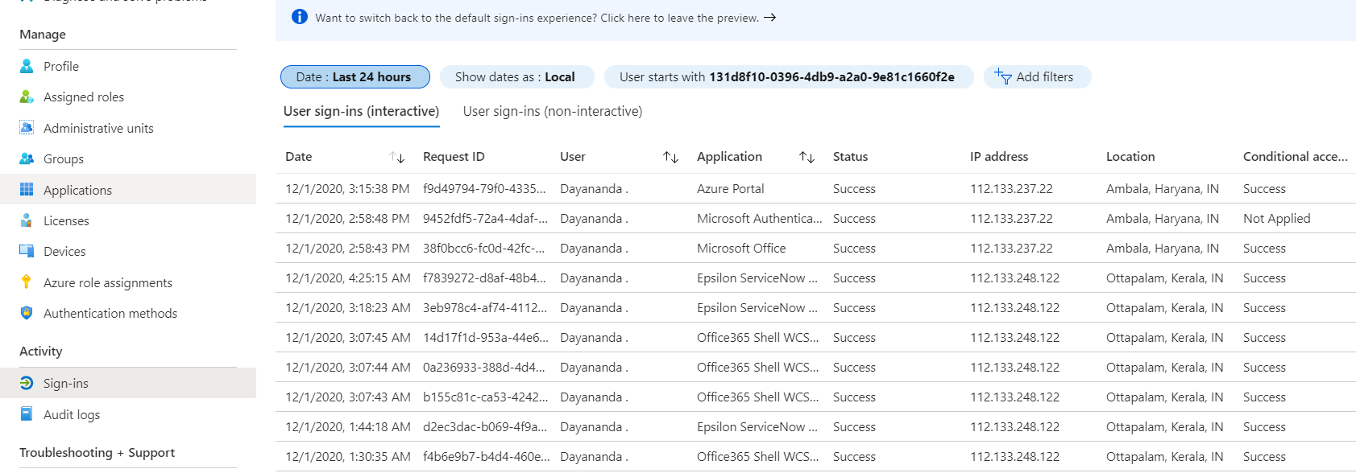

Check for MFA enable status and attempt to disable MFA

Collect these details and escalate the mail to GSO INCIDENT RESPONSE_RES_US <reportincident@publicisgroupe.com>

Case 2:
When malicious attachment opened by user
Contact the user and ask the user to connect with local IT team to perform AV scan on user machine or create a ticket in Publicis SNOW for scanning the machine
Inform the team/ user to provide the scan results

Send a mail to IR team with the status and ask them to check for any outbound connections to malicious source from user machine.

